Issuing Access for GIS Users
Access to edit individual maps can be issued by FireMapper Champions in the form of a temporary token for up to 14 days (Champions are listed on https://portal.fireandemergency.nz/projects-and-programmes/firemapper-for-enterprise-project/).

To Issue a New Token:
- From https://portal.firefront.com.au/
- Select shared maps 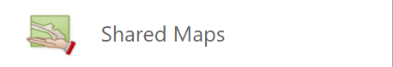
- Select “Create Shared Map Token” 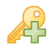
- Customise the token by, providing “name”, “expiry” and setting appropriate “permissions”
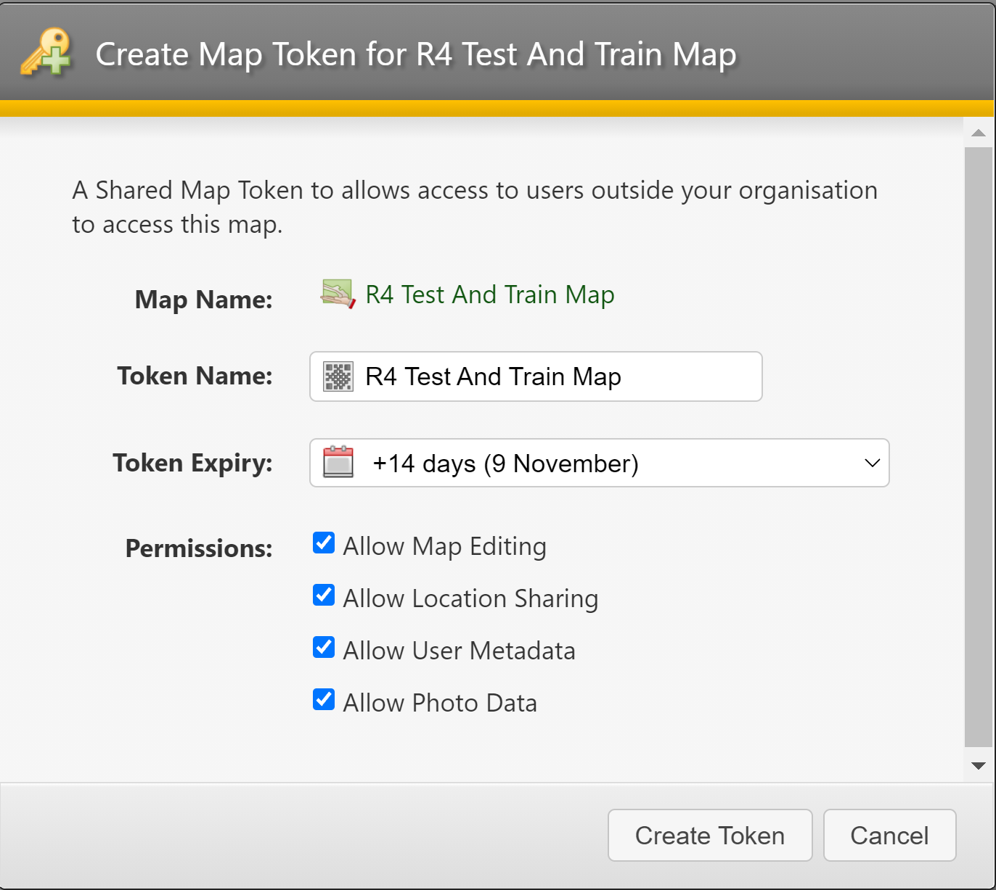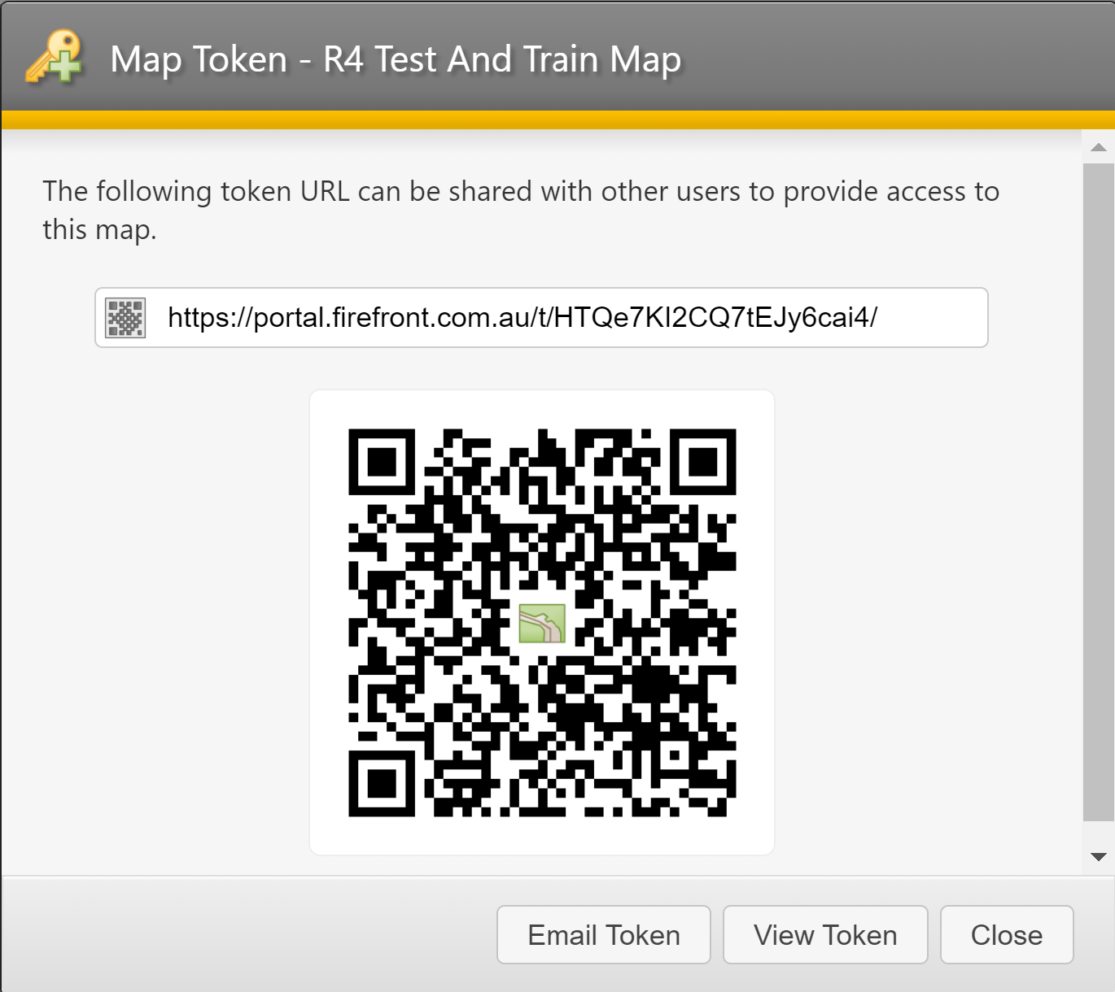
- The token can then be shared with the appropriate parties by sharing the link or QR that then pops up.
Warning: Tokens allow access to our maps and must be treated with the same security as usernames and passwords.

Accessing Existing Tokens
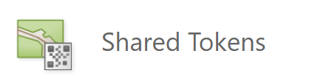
- Tokens that have not expired can be opened, edited, shared, through the “Shared Tokens” tab.

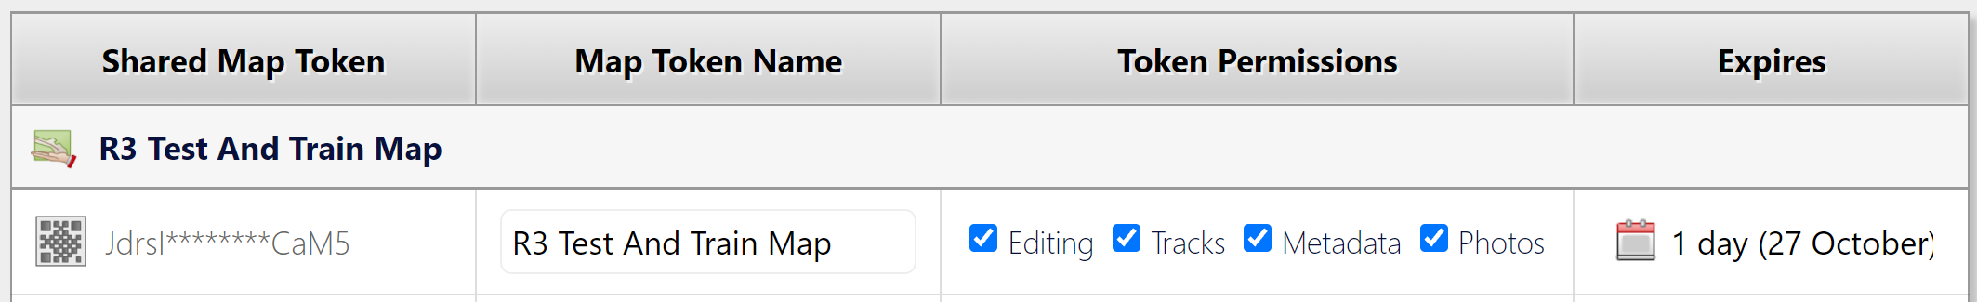
- Tokens can also be opened from the “Shared Maps” tab by selecting “Shares” column (active # of tokens are shown).
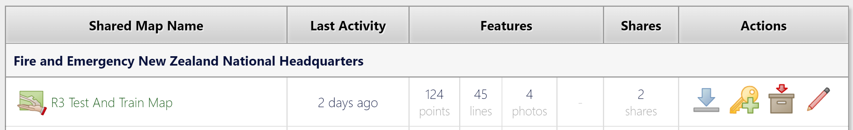

Renew Existing Tokens (to maintain GIS access to ongoing event)
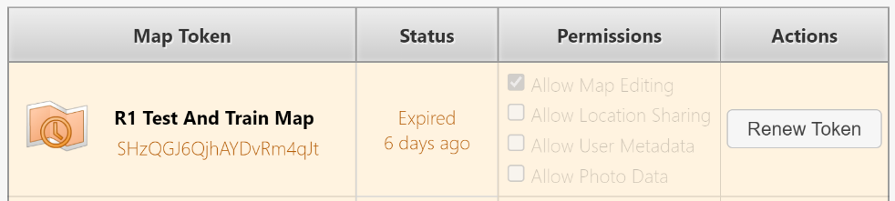
- Tokens that have expired can be renewed using “Shared Maps” tab and selecting Shares Column (even if empty) and selecting “Renew Token” from the list.

Opening a Map Token  Opening the link or the QR will bring up a selection of links to the map as well as download options.  Recommended GIS users access to live data feeds using the:  - Map Viewer (Quick Editing, IMT Briefings)  - ArcGIS Pro (Advanced Map Creation, Import Features)  These will provide live intel data and photos as the incident develops. GIS users can edit and moderate this content keeping incoming intelligence updated, and provide integration it with wider GIS data sources, including importing data sources like hotspots from GPX, KML or Shapefiles.  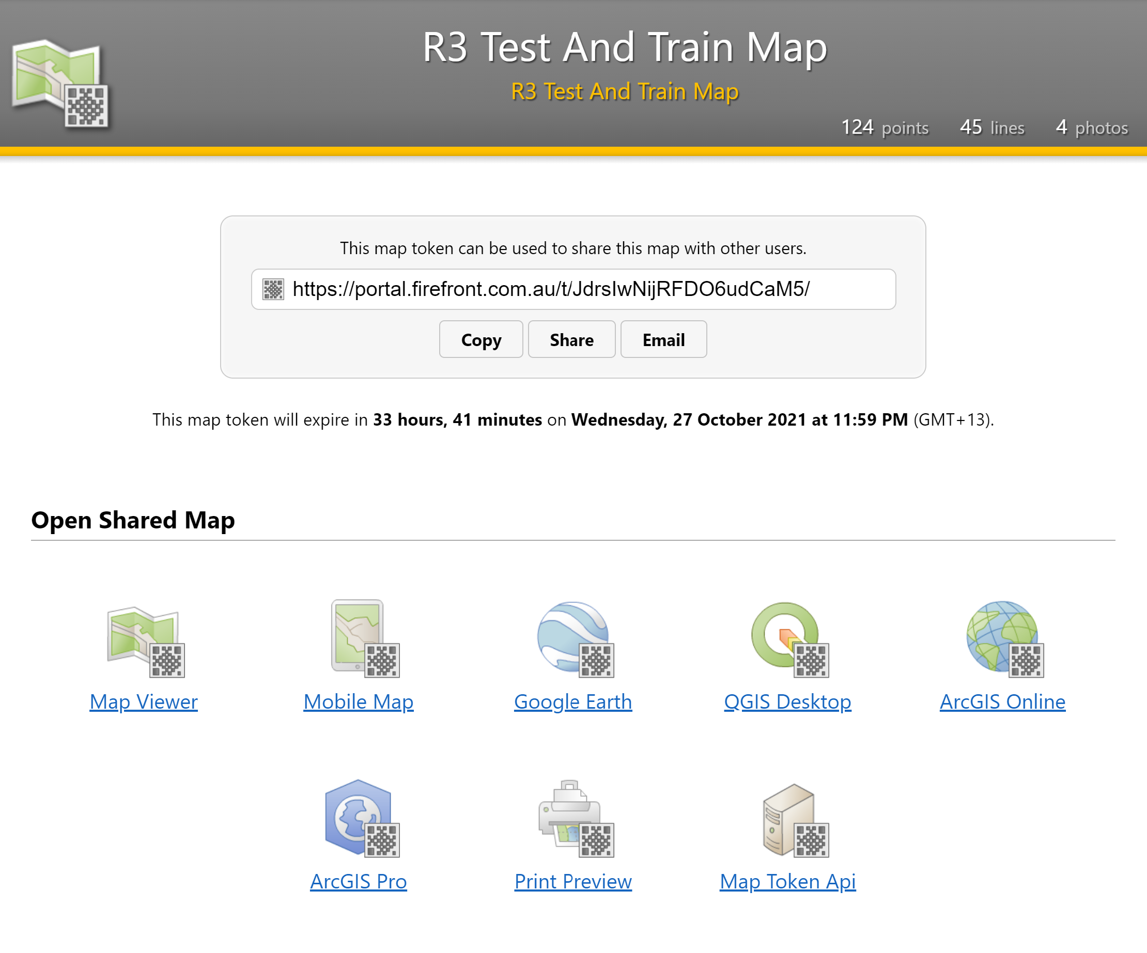 | Download Options  These options download static copy of data only. This is useful for archiving data throughout the event.  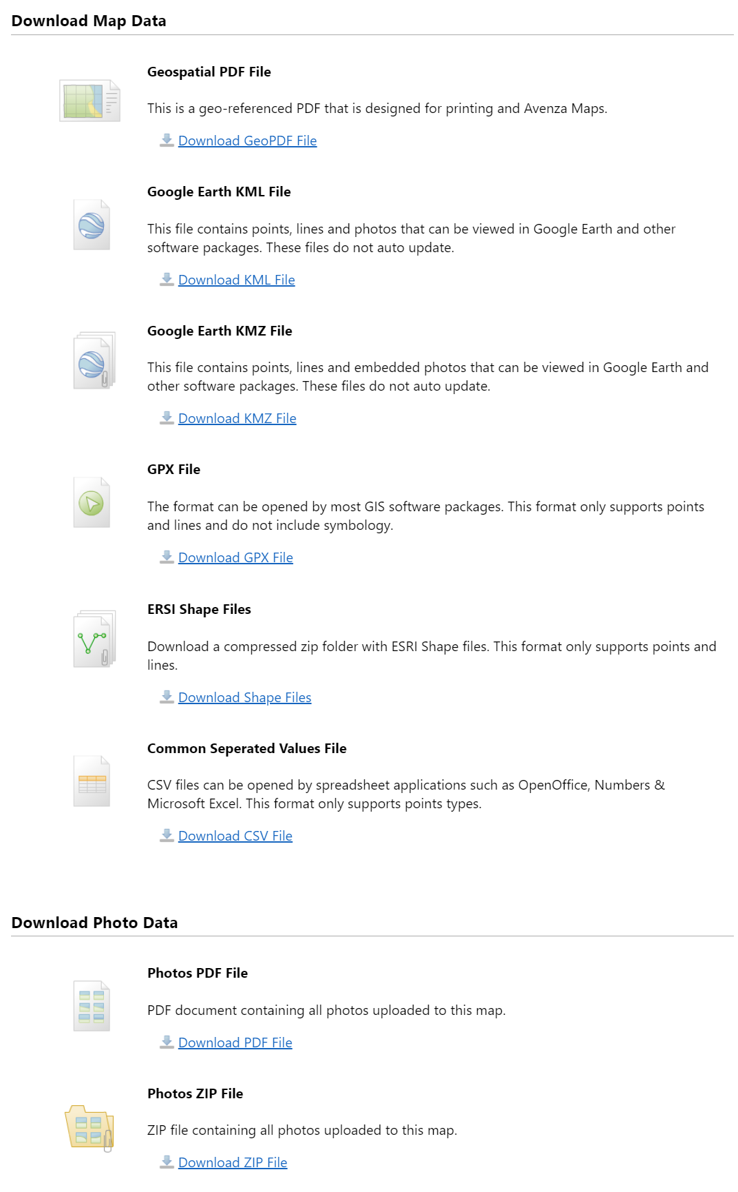
Editing Shared Maps in FireMapper Portal  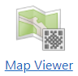  Use the Firemapper portal to maintain and edit map content for app users. This provides simple point, line and area feature mapping.  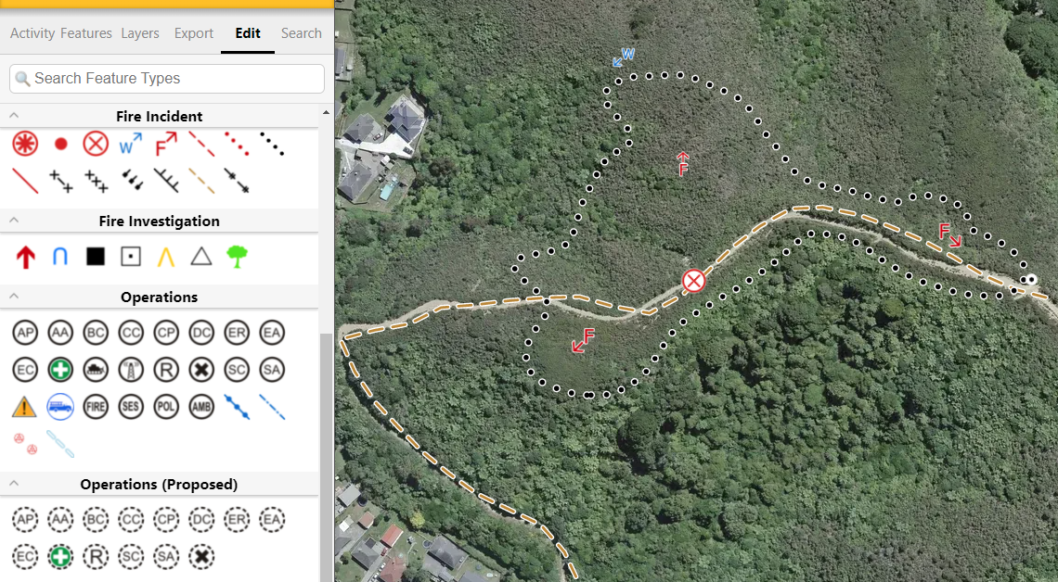 | Further Tutorials on Editing in FireMapper Portal  Upskill by accessing FireMapper Youtube site and review quick tutorials on using portal and app:  Fire Front Solutions - YouTube  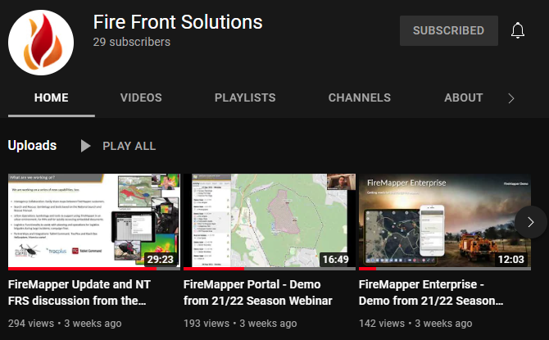

Opening FireMapper Live Data in ArcGIS Pro  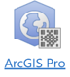  From the token link, select “Open Shared Map” then  This will download a SharedMapName.PITEMX file.  This PITEMX file provides the ArcGIS with the connection settings to the FireMapper live map feature layers  Double click on this file to open in ArcGIS Pro.  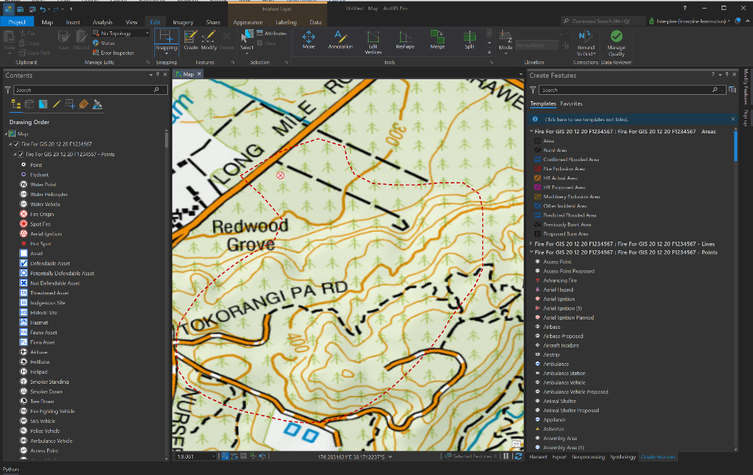 | Firemapper Live Map Layers in ArcGIS  Feature layers maintained by FireMapper and linked to your ArcGIS Project.  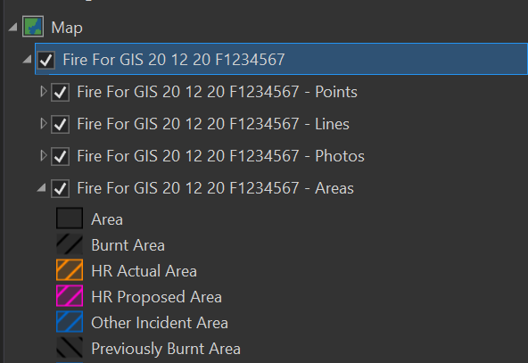  Points, Lines, Photos, Areas
“Adding FireMapper Layers to Existing ArcGIS Project
- Open PITEMX file in ArcGIS Pro
- Then drag and drop the live FireMapper Layer group into your own FireMapper Project File.

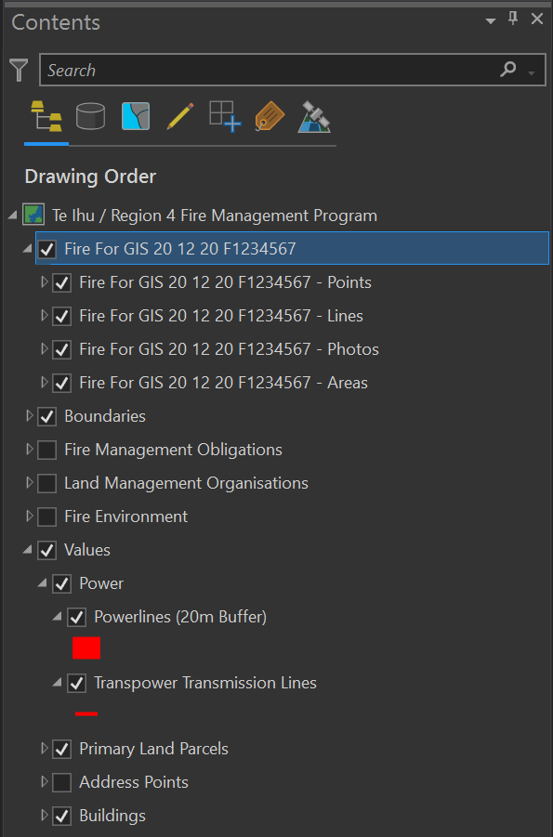
Data will remain live and updated with refresh within ArcGIS. If token expires, renew token rather than recreate to maintain access.
FireMapper Layers

Own
Project
Datasets
Editing in ArcGIS Pro
If token permits editing, normal GIS editing tools are available within ArcGIS to edit FireMapper Feature Layers.
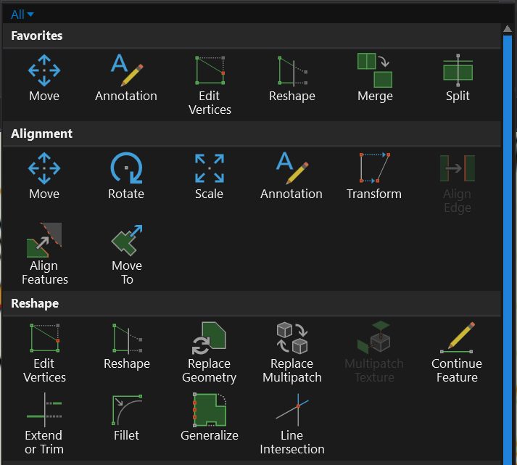

Importing Other Feature Data eg. HotSpots From GPX, KML
Use ArcGIS toolbox’s for “KML to Layer” or “GPX to Features” to bring data into ArcGIS Pro project.

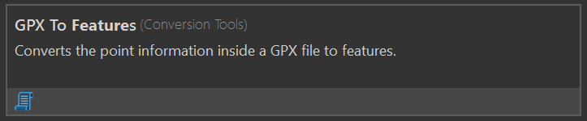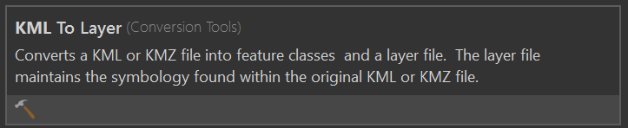

Once imported either digitise features into FireMapper layers using Create toolbar and pane, or use toolbox “Append” tool to bulk import.
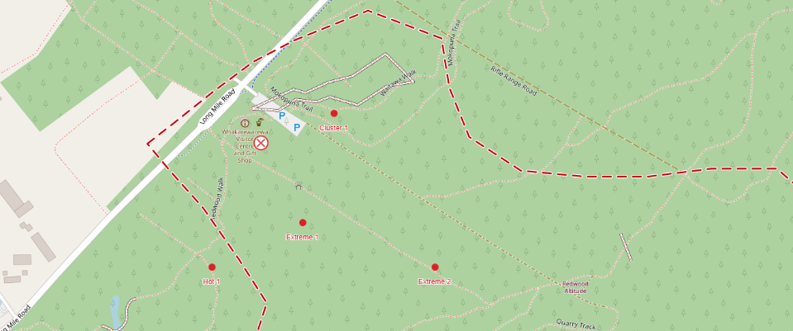
FAQ / Troubleshooting
- My map has gone? Fire Mapper PITEMX file opens a temporary map and location. Please save as at the start of Mapping production to secure the map.
- Can I rename a map on the portal as its been created with incorrect name. – No is example “Aware Bay” which should have been Awarua Bay at creation.
- Can you export the Symbology as a layer and use in other maps – Yes
- I’m experiencing editing issues - check token has correct permissions and current.
- Delays in the update of data between FireMapper app and arcpro. Check the app user has shared the data and synced map, check if data is showing on the portal or close the map and reopen.
- If the Firemapper app users map will not Sync with an error of “Android hotfix 364 feature already exists in same location!“ in the app, get them to identify and remove points less than 5m apart, then resync
- Further support: David.Herries@Interpine.nz or Craig.MacAlpine@FireandEmergency.nz

FireMapper Enterprise
FENZ Feature Key

